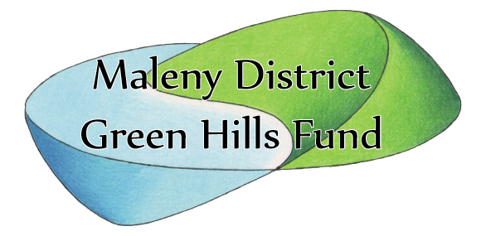APPLICATION FOR MEMBERSHIP
Maleny & District Green Hills Fund
ABN 86 071 444 123

I hereby apply for membership of the association and agree to be bound by its rules & regulations.
SURNAME.........................................................................................
FIRST NAME(S).................................................................................
POSTAL ADDRESS................ ………………………………………….
……………………………………………………………………….Postcode ...................
RESIDENTIAL ADDRESS...…………………………………………………………………
PHONE........………………………………….
E-mail...........………………………………………………………………..
(we respect your privacy and use bcc in correspondance)
APPLICANTS SIGNATURE ...........................................................
PROPOSED BY.......................................................
SECONDED BY ......................................................

Membership runs 12 months from renewal
I attach cash/cheque for annual subscription of $10.00 $.......................
Please accept my further donation of (payable to MDGHF ) $.....................
Total $.......direct deposit
Date: _______/_______/_______.

If paying by direct deposit: Suncorp Maleny
BSB 484-799
A/c 605 400 520
Please write your name on deposit form so we know who it came from!
If paying by cheque make (payable to MDGHF) and post to:
MDGHF, PO Box 662, Maleny Q 4552
Any questions? Email membership secretary at: info@greenhills.org.au
Office use only:
Payment received by: DD [ ] Check [ ] Cash [ ] Other [ ]
Form sent to membership officer: Date: ………/…………/…….

